Code:

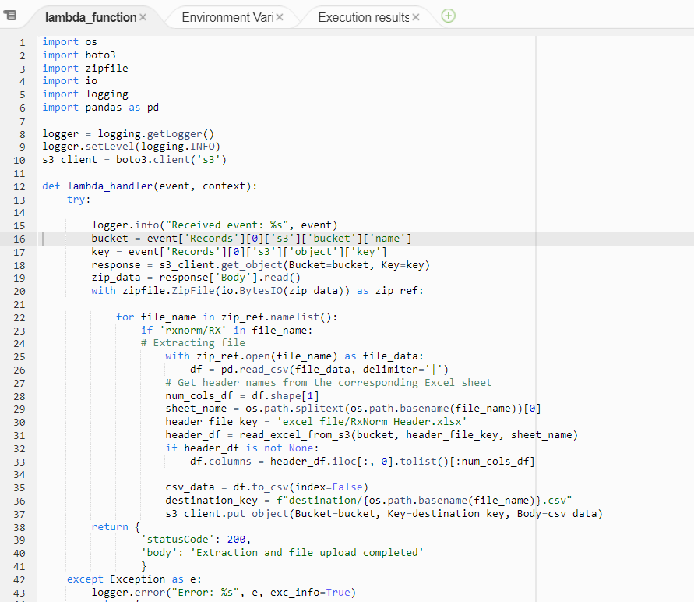

Zip File in source folder:

Files Transferred in destination folder:

Excel file with header:

